Yashkumar Patel

Q1:

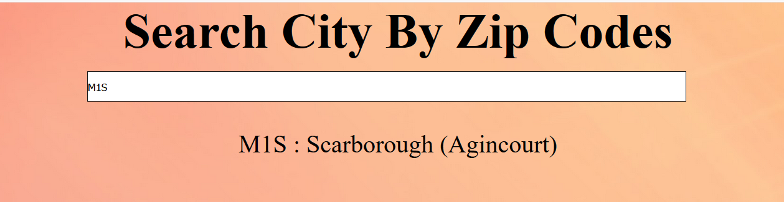

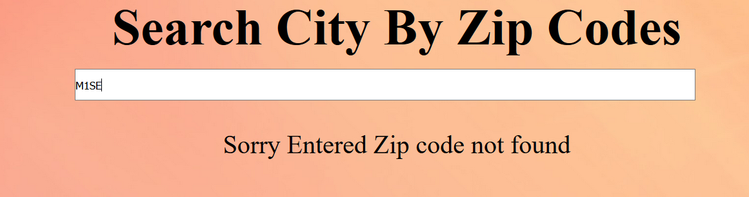

Q2:

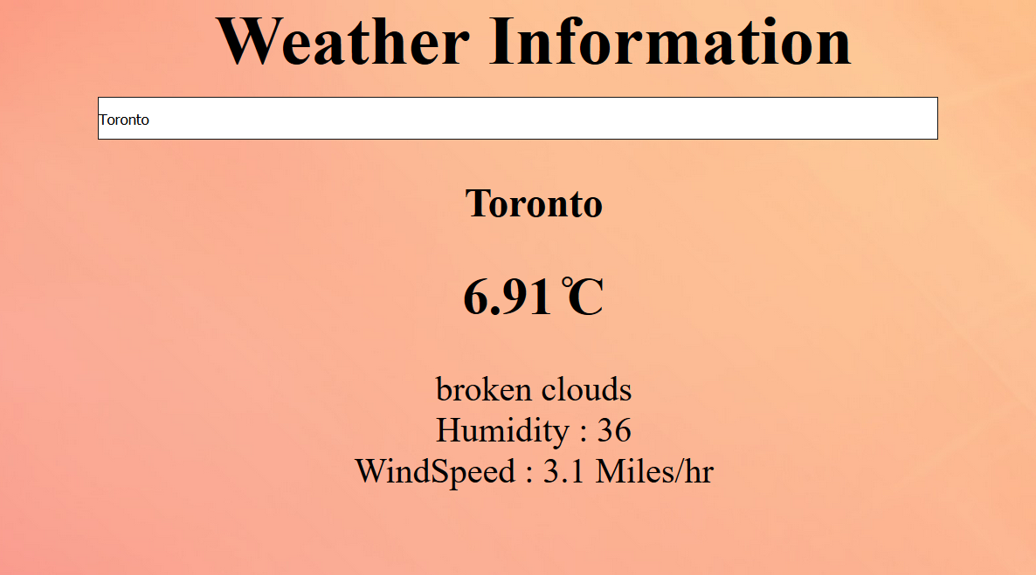

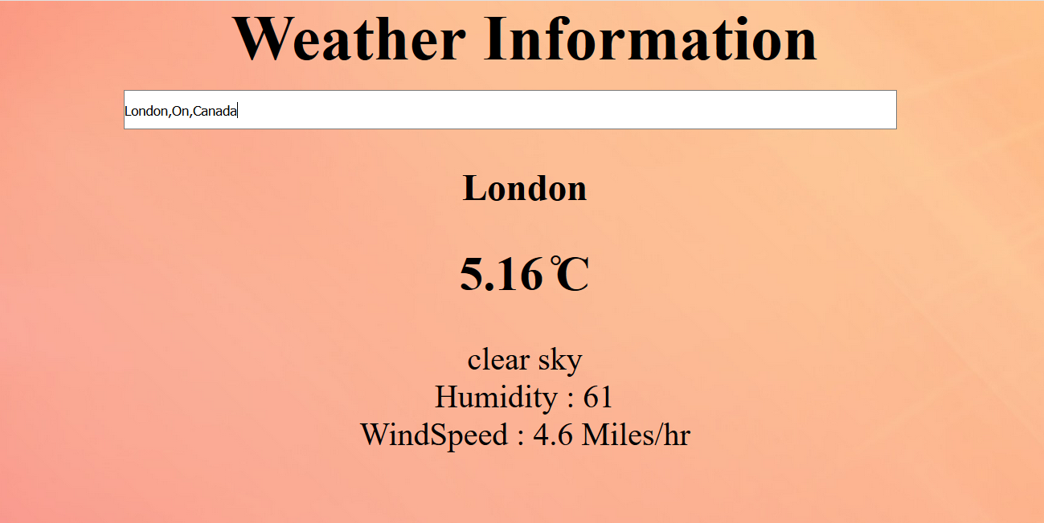

Q3:

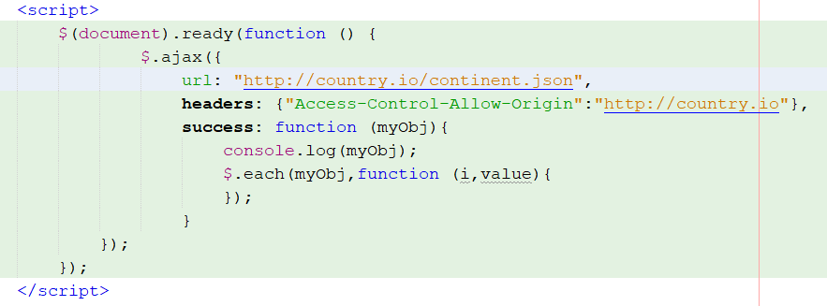



Reason for the Error is CORS header “Access-Control-Allow-Origin” is missing so Ajax cannot do take data from Website.

Tried to add header to the header using ajax but it was not working.